**Ordering food in Tuwaiq Academy**

### (Backend project)

Introduction

Ordering food in Tuwaiq academy is a website that can help All in Tuwaiq academy to make order online for reduce their time and effort in breaks time. This website allows users to register as a merchant to add products or users to order food and drink to be ready in breaks .

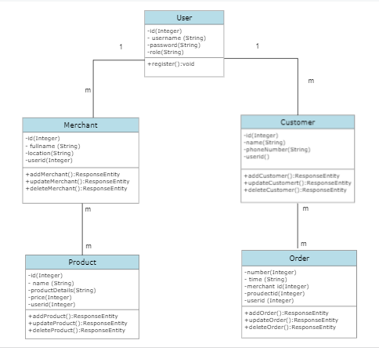Class Diagram